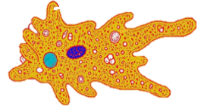

1. GIBANJE DIJELOVA TIJELA

**BILJKE**

a) Podražaj **1** ___________________

b) Opiši reakciju biljke na podražaj 1

________________________________________________________________

**JEDNOSTANIČNI ORGANIZMI**

b) Koji dio stanice je odgovoran za primanje podražaja.

________________________________________________________________

a) Navedi primjer reakcije na neki podražaj.

________________________________________________________________

REAGIRAJU LI SVA ŽIVA BIĆA NA PODRAŽAJE

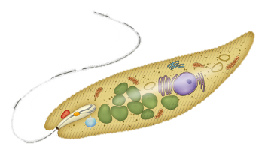

**GLJIVE**

b) GIBANJE KLOROPLASTA

a) GIBANJE PUČI

2. GIBANJE ORGANELA

**BILJKE**

g) Podražaj **4** ___________________

h) Na primjeru opiši reakciju biljke na podražaj 4

________________________________________________________________

e) Podražaj **3** ___________________

f) Na primjeru opiši reakciju biljke na podražaj **3**

________________________________________________________________

c) Podražaj **2**  ___________________

d) Opiši reakciju biljke na podražaj **2**

________________________________________________________________

Na primjeru opiši reakciju gljive na podražaj.

________________________________________________________________

________________________________