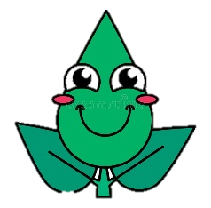I biljke osjećaju!

1. Promotrite slike koje prikazuju reakciju biljaka na određeni podražaj.

a) Navedite naziv podražaja.

b) Opišite reakciju biljke na podražaj.

I. 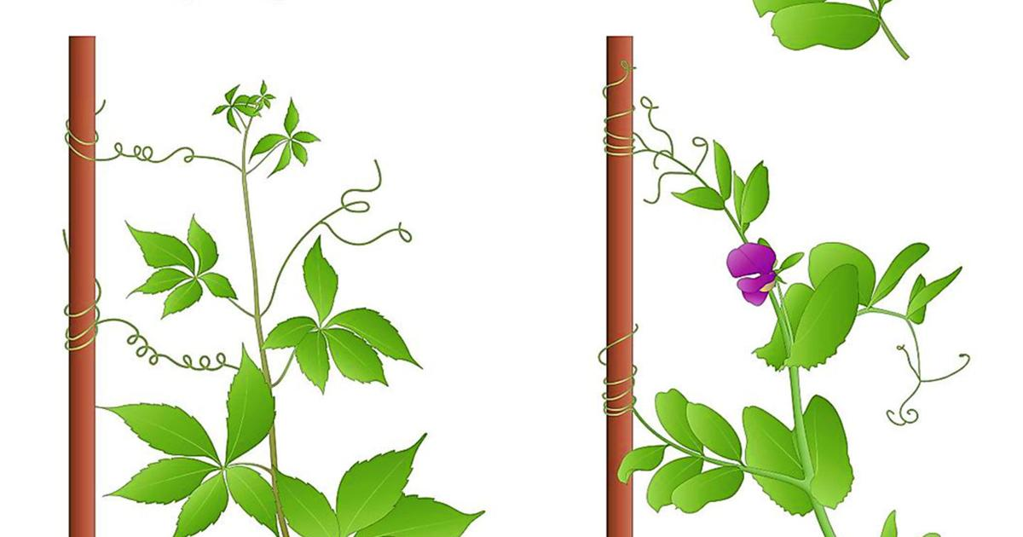

a) ___________________________________

b) ___________________________________________________________________

___________________________________________________________________

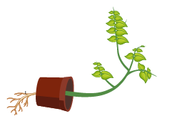

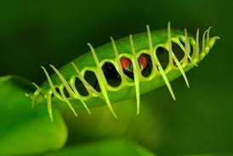

II. 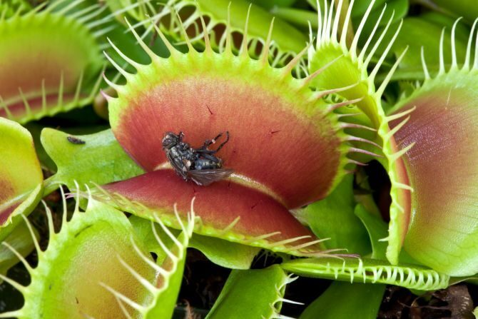

a) ___________________________________

b) ___________________________________________________________________

___________________________________________________________________

2. Pripremite kratko izlaganje o vašoj temi.